THE UNIVERSITY OF DANANG
THE UNIVERSITY OF TECHNOLOGY
FACULTY OF ELECTRONICS AND TELECOMMUNICATION



FINAL REPORT
MICROPROCESSOR ENGINEERING
TOPIC:
CO AND PM2.5 CONCENTRATION MONITORING DEVICE

Group name: | Everythin’ Is Under Ctrl
Group members: | Trần Quang Khánh (106220220)  Lê Xuân Nam (106220226)  Hồ Anh Nguyên (106220228)  Phan Lê Minh (106220260)
Academic supervisor: | M. Sc. Hồ Viết Việt
Course class: | 22.44A

Da Nang, 2025
- Introduction:
- Carbon monoxide (CO) and PM2.5 are hazardous air pollutants that pose serious risks to human health if not monitored and detected in a timely manner. Prolonged exposure can lead to respiratory problems, cardiovascular diseases, and life-threatening conditions. For example, the AQI in Hanoi city during winter is usually around the alarming level due to these two pollutants. Therefore, developing an effective air quality monitoring and warning device is essential.
- This project aims to design a device for monitoring and warning of CO and PM2.5 concentration levels.
- The system uses CO and PM2.5 sensors and an ESP32-C3 microcontroller to measure the concentration of these two elements and generate warning signals.
- Useful applications: indoor air quality monitoring, fire detection, smart safety systems.
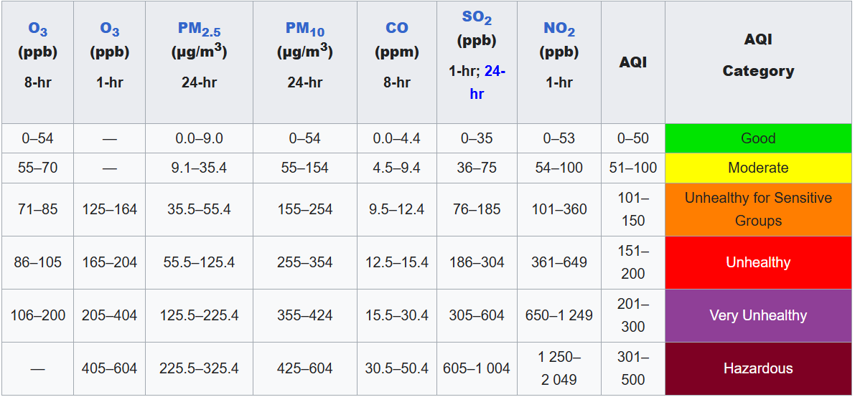
Figure 1: Air Quality Index (AQI) Standards for Major Air Pollutants [1]
- Hardware Schematic and Components Used:
- Components used:
  - Main MCU: ESP32-C3 DevKit-M1.
  - Smoke Sensor: MQ-2.
  - PM2.5 Sensor: GP2Y1010AU0F.
  - Indicators: 2 LEDs, 1 buzzer, and 1 push button, 3 resistors.
  - Displays: 1 LCD 16x2 I2C.
  - Capacitor: 220uF/16V.
- General block diagram:
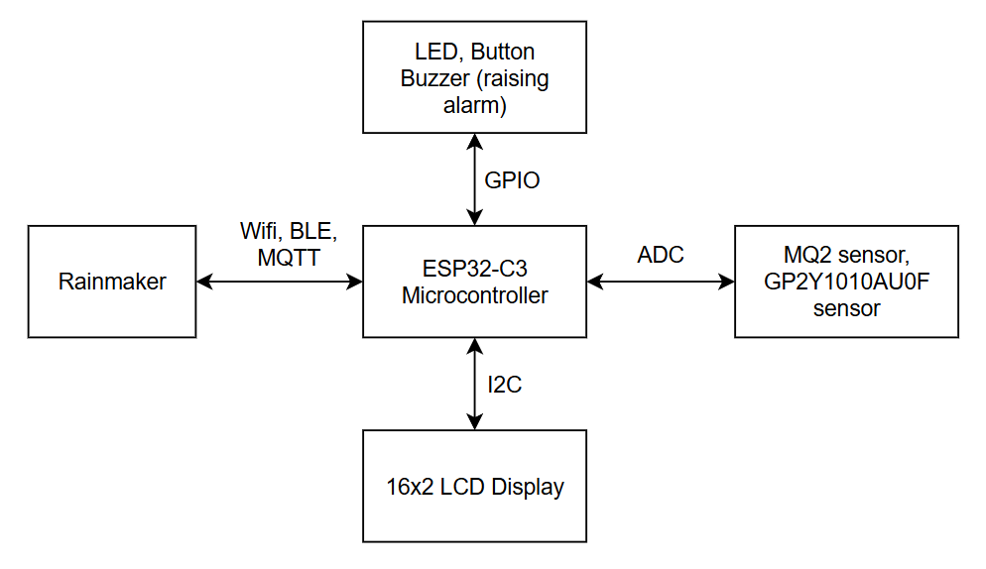
Figure 2: Block diagram
- Circuit diagram:
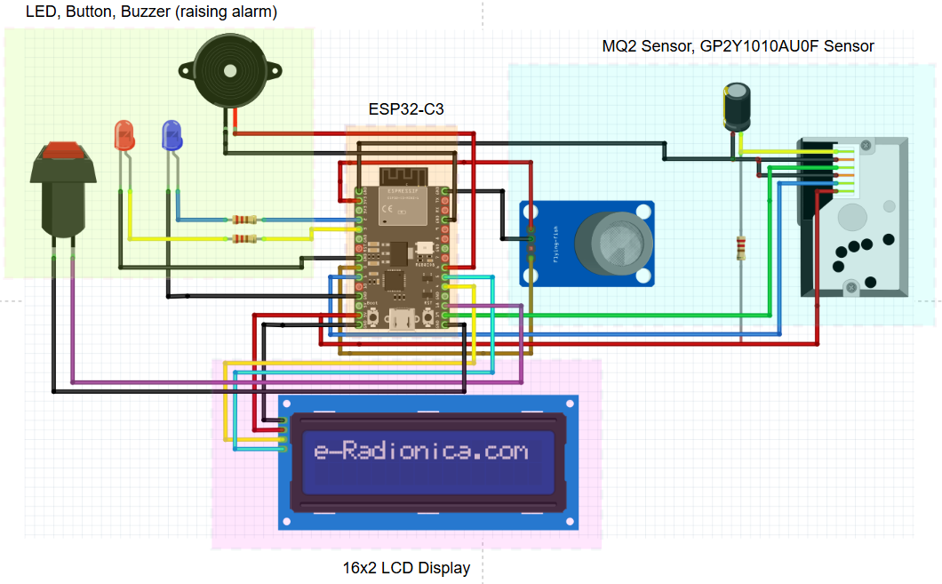
Figure 3: Circuit diagram
- Functions of the components:
  - ESP32-C3 microcontroller: Acts as the central processing unit of the system.
  - MQ-2 sensor: Detects CO gas and converts it into a concentration value in ppm. (AO connected to GPIO0, and VCC=3.3V) [3]
  - GP2Y1010AU0F: Detects PM2.5 and converts the ADC values from PM2.5 to a concentration value in µg/m³. (With VO connected to GPIO1, IR LED on GPIO19, and VCC = 5V) [2]
  - LEDs: Indicate status and alarm conditions. Current-limiting resistors are used to protect the LEDs (Blue LED on GPIO2, red LED on GPIO3).
  - Buzzer: Generates audible warning signals (GPIO6).
  - Push button: Used to activate alarm mode or not (GPIO18).
  - LCD I2C: Displays the CO and PM2.5 concentration value (SDA on GPIO4, SCL on GPIO5).
  - Capacitor: Used for reducing noise and stabilizing the GP2Y sensor’s ADC signal.
- Implementation:
Software tools used by the team:
- ESP-IDF (C/C++): Used for programming, in order to run the entire system.
- Rainmaker: Used for monitoring the concentration of CO and PM2.5 and pushing warning notifications.
- Draw.io: Used to design the overall system flowchart and block diagram.
- Fritzing: Used to visualize the circuit diagram (mainly for reporting purposes, mentioned in Figure 3).
Flowchart:
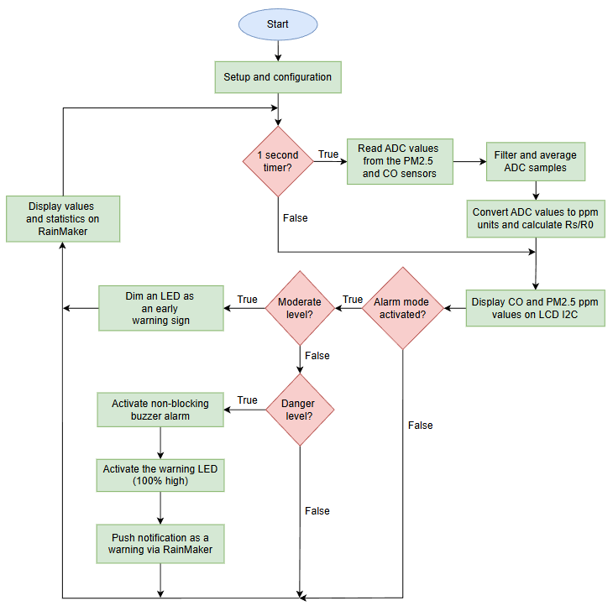
Figure 4: Flowchart
Implemented circuit and RainMaker:
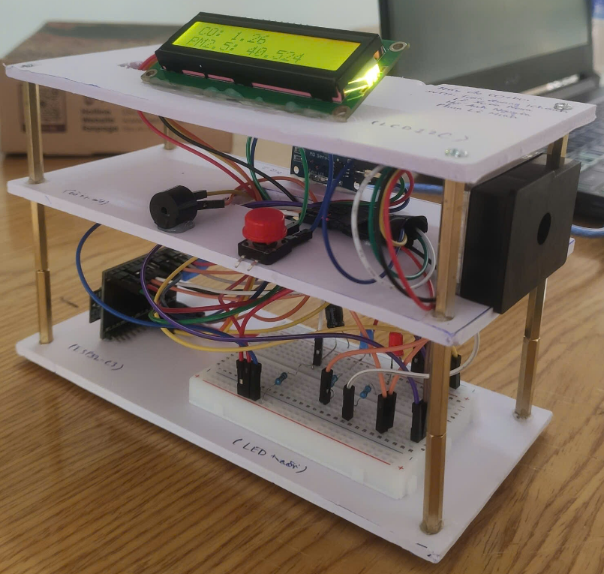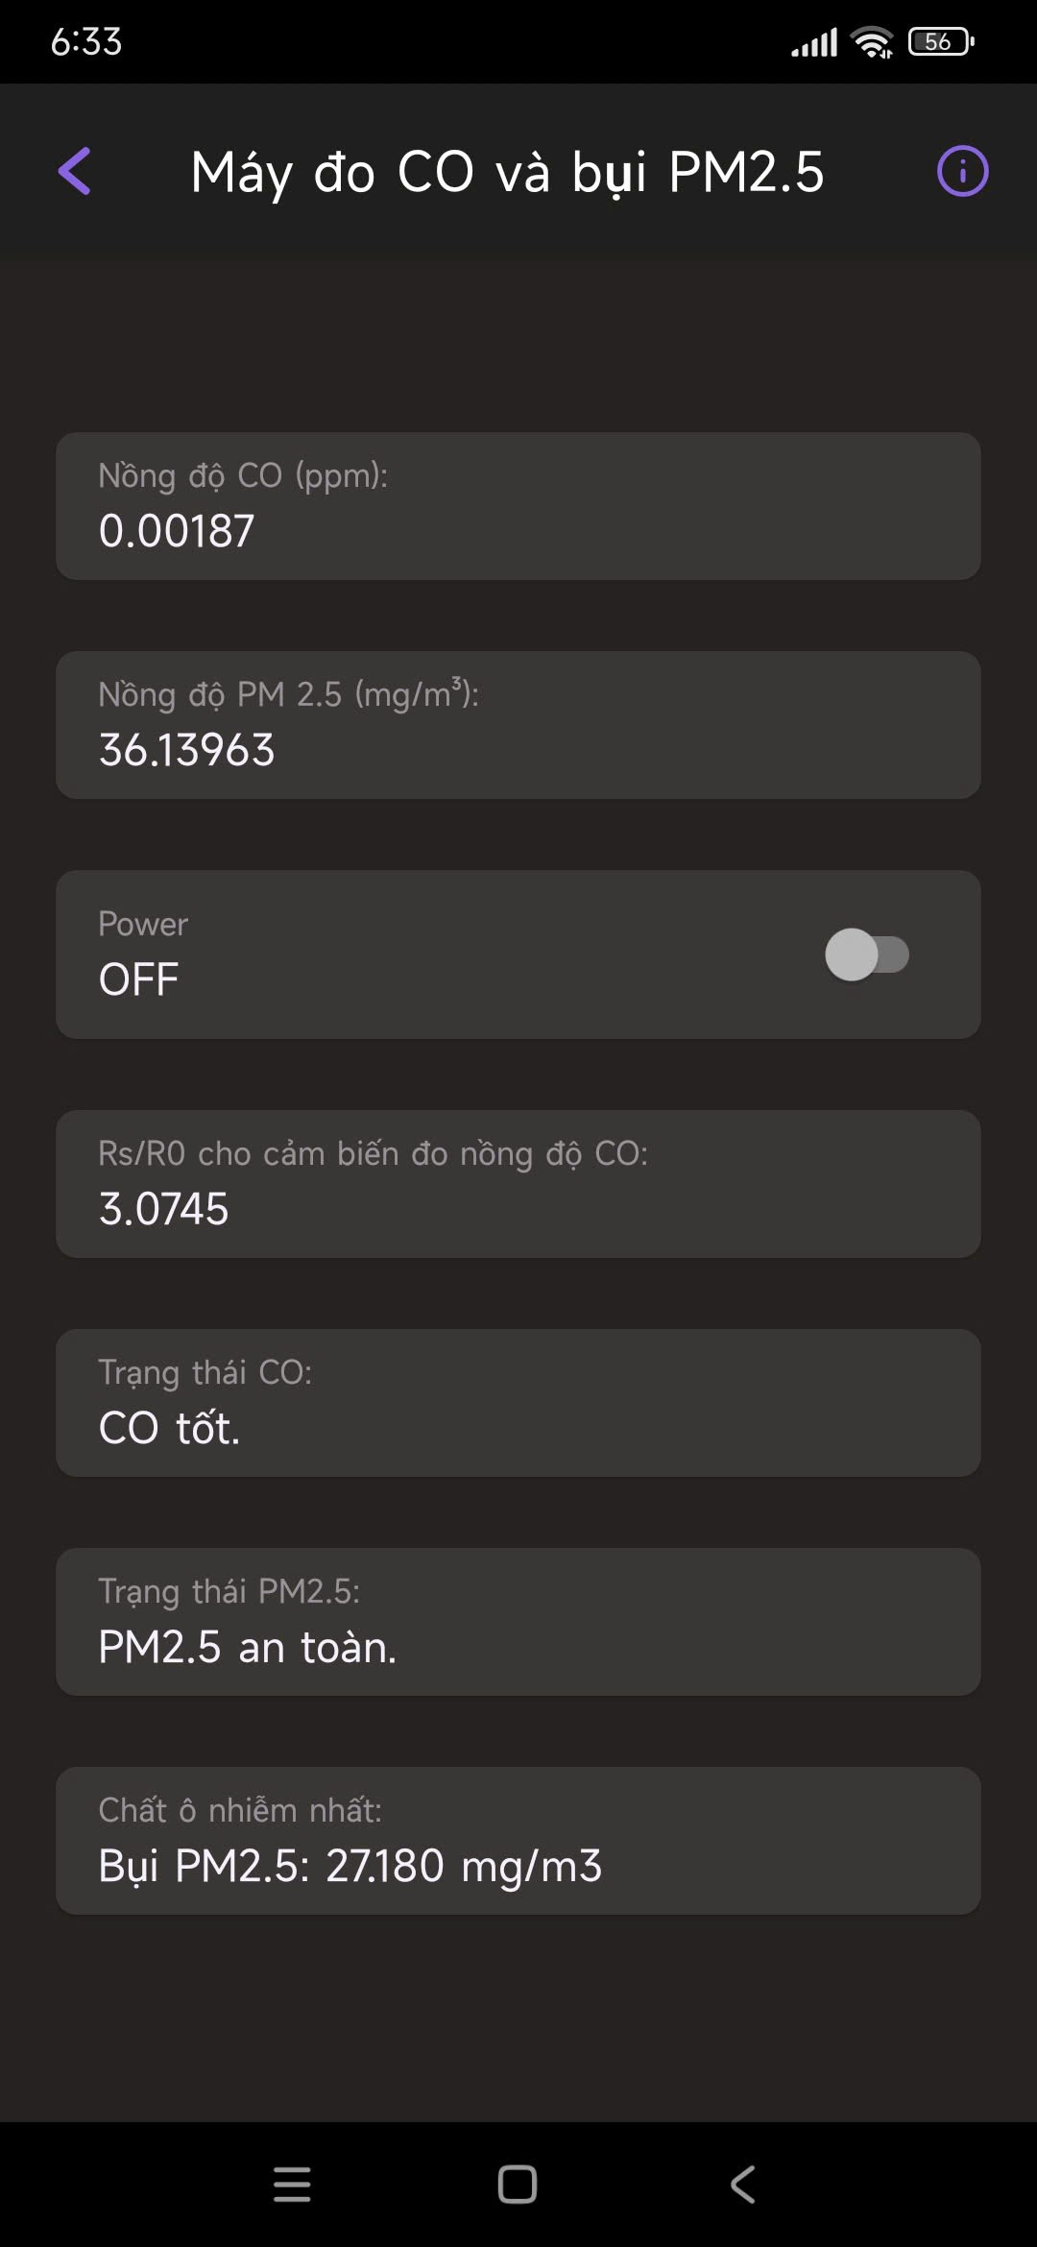
Figure 5: Implemented circuit and RainMaker
- Conclusion:
- The project has implemented a CO and PM2.5 concentration monitor device based on the MQ-2 sensor, GP2Y1010AU0F sensor and an ESP32-C3.
- The system can monitor CO levels, display information, and activate alarms when the concentration reach the hazardous level.
- Thanks to ESP Rainmaker, this application has enabled remote monitoring, alarm mode control, and the display of hazardous warning notifications.
- References:
[1] U.S. Environmental Protection Agency, Air Quality Index, Wikipedia.
[2] ESPBoards, GP2Y1010AU0F Dust Sensor – Overview and Usage.
[3] M. Karim, Arduino and MQ-2 Gas Sensor, Arduino Project Hub.

